**Milestone 03**



**Spring 2025**

Submitted by:

FAIZAN 2134

ANEES 2168

ZEESHAN 2217

Class Section: **B**

“On my honor, as student of University of Engineering and Technology, I have neither given nor received unauthorized assistance on this academic work.”

Submitted to:

Eng. Sumayyea Salahuddin

Month Day, Year (02 06, 2025)

Department of Computer Systems Engineering

University of Engineering and Technology, Peshawar

### **Relationships Between Tables**:

1. **User (1) -> Booking (Many)**: One user can have many bookings.
2. **Room (1) -> Booking (Many)**: One room can have many bookings.
3. **User (1) -> Contact (Many)**: One user can submit many contact requests.
4. **Room** and **Contact** have no direct relationship.

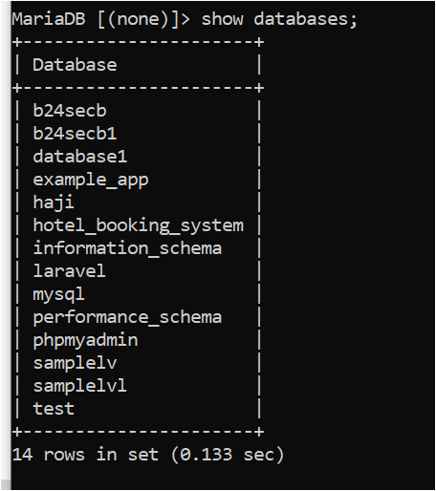

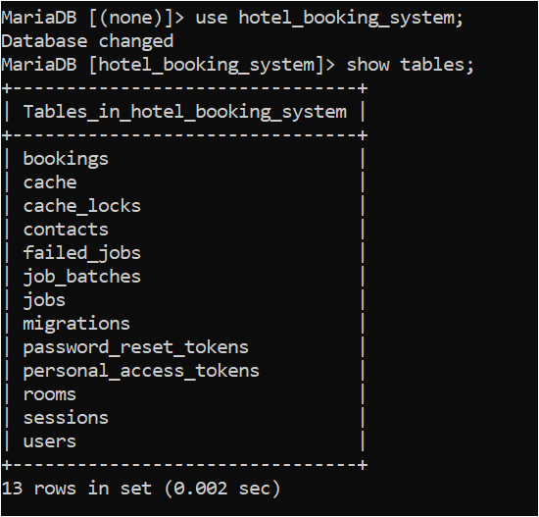

Tables;

Bookings;

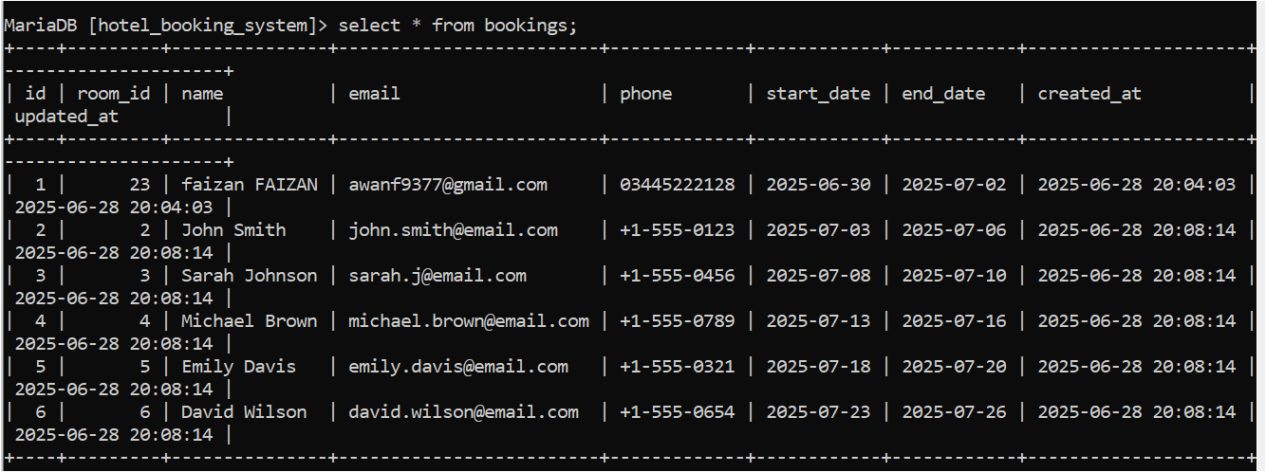  
describe table;  
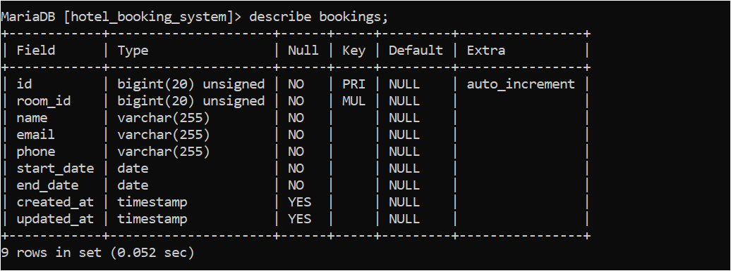

Table user :

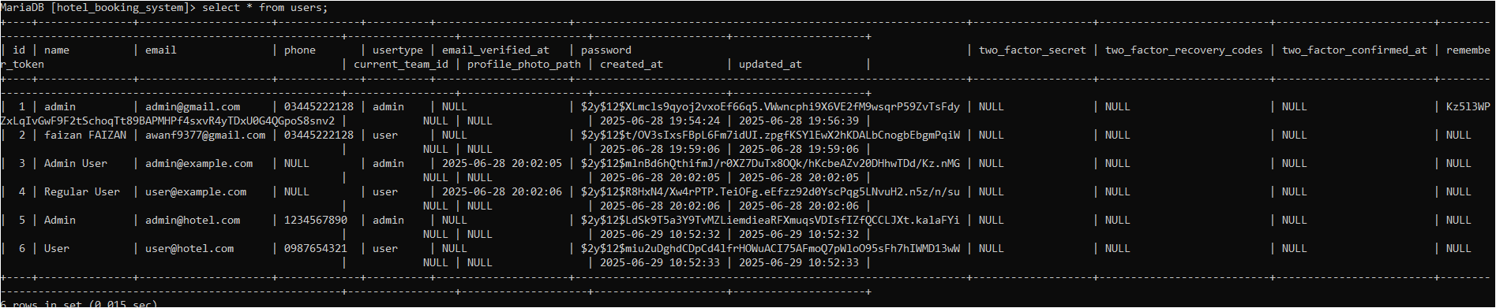

Describe :  
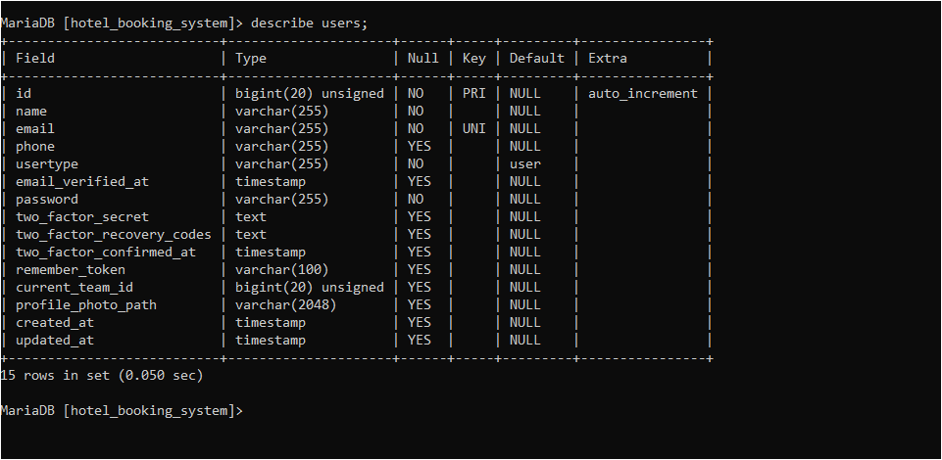

Table Rooms:

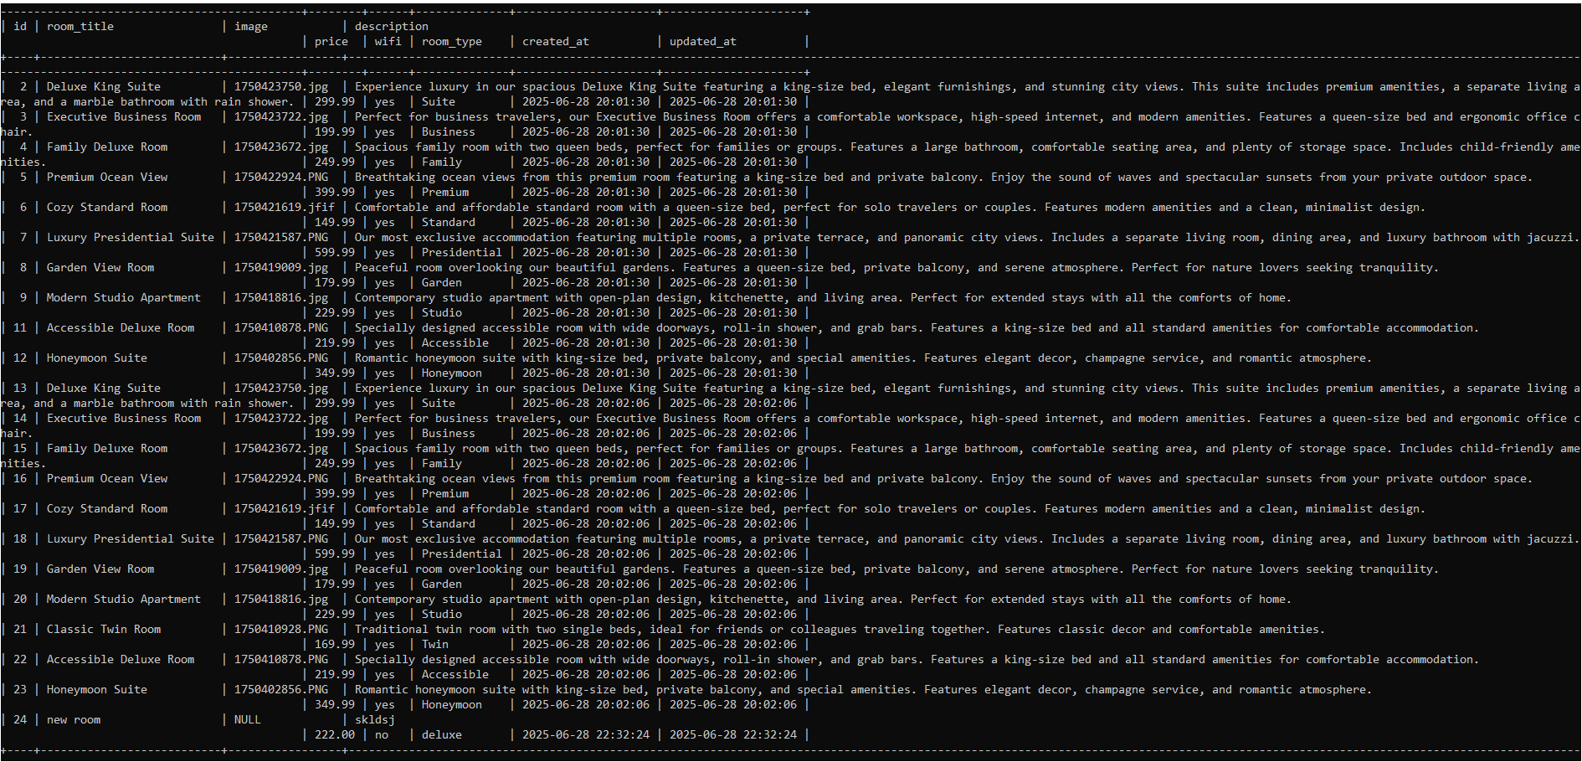

Describe :

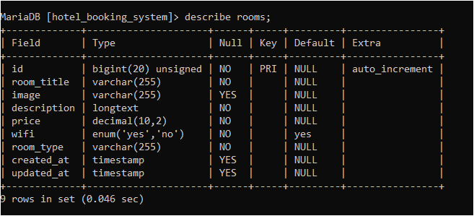

Table contact:

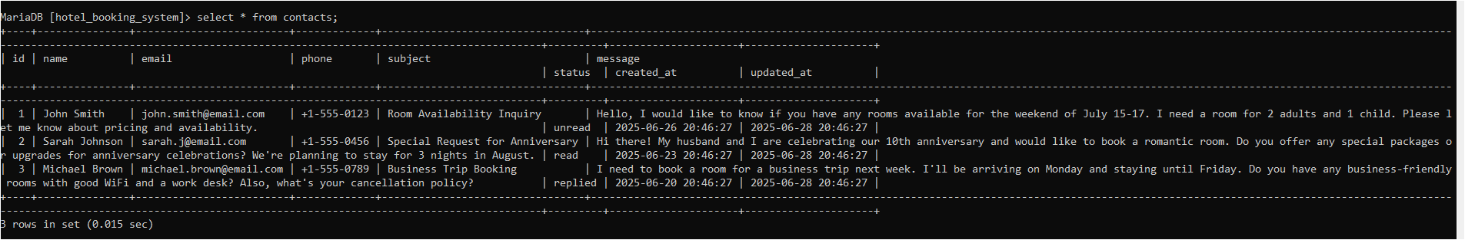

Describe :

